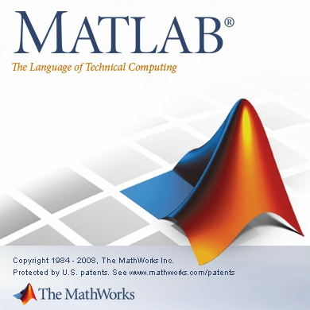

What is MATLAB?

MATLAB (**mat**rix **lab**oratory) is a commercial software that acts as both a fourth generation programming language and an interactive programming environment. Many colleges and researchers use MATLAB as the preferred programming language. It is a “matrix laboratory” which means it is very fast at manipulating and analyzing data given in the form of numbers in a matrix. It excels as numerical computations and visualizations of graphs/data. There are also symbolic computing and simulation capabilities via optional add-ons.

How to get MATLAB

Buying MATLAB commercially for a single-user license can be upwards of $2000 for the initial purchase and subsequent maintenance. So don’t buy it! Most colleges will offer this program for free to students and Mr. Kummer offers an array of student version DVD’s along with installation and activation keys. *What a kind soul.*

Getting Started

Insert the MATLAB disc into the computer and run by opening the CD/DVD and clicking setup.exe. You must have administrator privileges to install the disc. Agree to all the conditions and allow files to be copied over. Type in the installation and activation keys when prompted. Installation should be simple and straightforward.

Coding Environment

MATLAB looks similar to a command prompt, with **>>** signifying the start of each new line. (TIP: typing **help** will bring up a list of help topics) One of the most common questions is how to leave MATLAB. Typing either **quit** or **exit** will close the program. The next few sections will run through the creation of matrices and variables. Then, basic functions to manipulate such data will be given.

Matrices

**rand(***n***)**

Makes a randomly generated matrix with elements between [0, 1) of side length *n*

**rand(***rows***,** *columns***)**

Makes a randomly generated matrix with elements between [0, 1)

**hilb(***n***)**

Makes a Hilbert matrix of side length *n*

**magic(***n***)**

Makes a magic square of side length *n*

**eye(***n***)**

Makes an identity matrix of side length *n*

**zeros(***rows***,** *columns***)**

Makes a matrix of side length *n* with elements of 0

**ones(***n***)**

Makes a matrix of side length *n* with elements of 1

Blocked matrices can be made using different types of matrices by combining functions like **[eye(2);zeros(2)]**. Note that the dimensions have to be compatible or MATLAB with throw an error.

Programming Tools (Loops and Tests)

The format of the if-test in Matlab is extremely similar to that of Java, however, the keyword “end” is needed to break out of the test. In addition, syntax for outputting text to the user is through the keyword “disp” with the output in single quotes and parentheses.

**if overallMean < .49**

**disp('Mean is less than expected')**

**elseif overallMean > .51**

**disp('Mean is greater than expected')**

**else**

**disp('Mean is within the expected range')**

**end**

The format of the Matlab for-loop is similar to that of the enhanced for loop in Java. The front line of the for loop requires an initialized variable, a colon, and then the upper bound limit to the loop. The loop is executed as normal, however in order to break out of the loop, the keyword “end “is used just as seen with the if-test.

**for k = 1:nsamples**

**currentData = rand(npoints,1);**

**sampleMean(k) = mean(currentData);**

**end**

Helpful Links

MATLAB Summary and Tutorial (<http://www.math.ufl.edu/help/matlab-tutorial/>)

A complete tutorial from which this tutorial was adapted and includes a run-through of functions with examples

Introduction to MATLAB (<http://web.gps.caltech.edu/classes/ge11d/doc/matlab_Resource_Seminar.pdf>)

Gives a simple introduction to the language and basic coding help

MATLAB (<http://www.mathworks.com/academia/student_center/tutorials/launchpad.html>)

The official site of MATLAB, including interactive tutorials (may take longer than other tutorials)